**AIRPLANE CRASH**

**1.Introduction**

**1.1 overview**

An airplane crash analysis is a detailed investigation into the causes of an aviation accident. The goal of an airplane crash analysis is to identify any factors that contributed to the accident, with the ultimate goal of improving safety and preventing future accidents. The process of conducting an airplane crash analysis typically involves the collection and analysis of a wide range of data, including information about the aircraft and its systems, the operators, and any other relevant factors. This data is typically collected from Kaggle. Once the data has been collected, it is analysed through tableau, to identify any potential causes of the accident. The results of an airplane crash analysis are typically published in a report, which may include recommendations for improving safety and preventing similar accidents in the future. These recommendations may be implemented by the relevant authorities or industry organization.

**1.2 Purpose**

A literature survey is a method of researching existing literature and studies related to a specific topic. In the context of analysing the airplane crash, a literature survey would involve reviewing studies and articles that have been published on the topic of airplane crash, as well as studies specific to crash analysis. The literature survey would include sources such as academic journals, industry reports, and online articles. The literature survey would also explore any existing research on airplane crash, and would aim to identify any unique challenges or opportunities that to overcome crash

**2. Problem defining and desing thinking**

**2.1**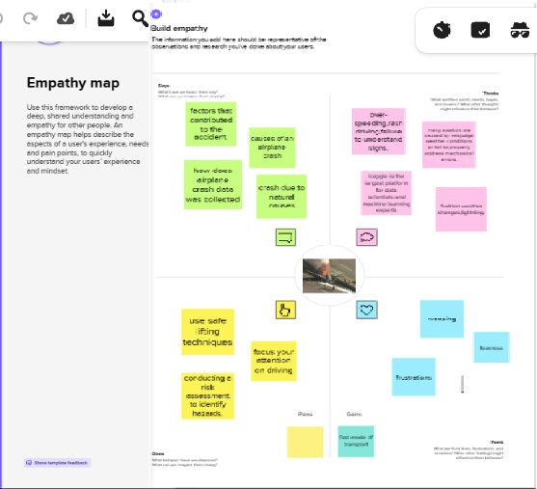

**2.2 Identation and brainstorming**



3.**RESULT**

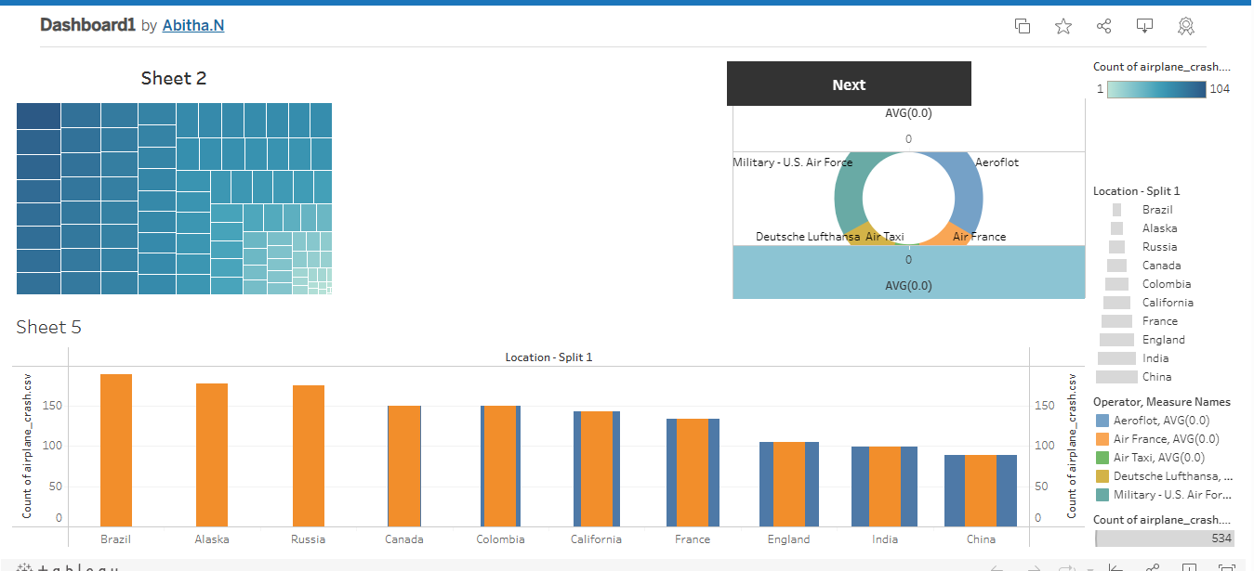

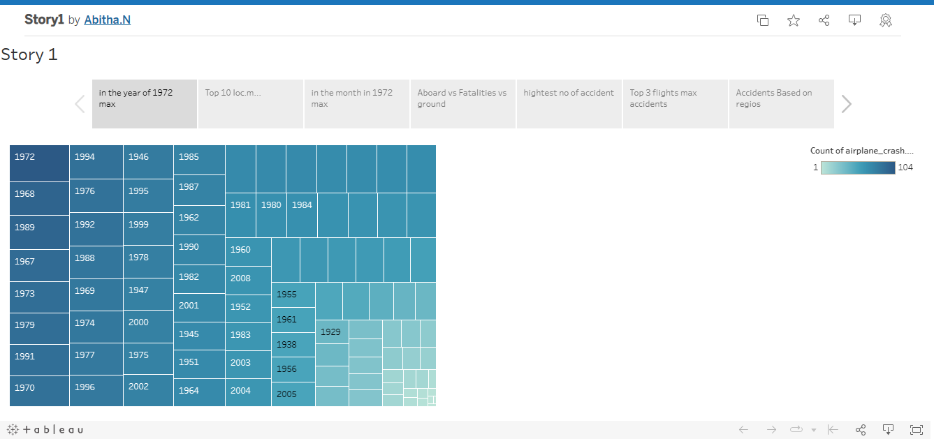

**4.Advantages**

* Aircraft accident investigation involves the collection and analysis of various data in order to draw conclusions and make safety recommendations that will prevent aircraft accidents caused by similar causes in the future. Therefore, a properly conducted investigation is **a key to prevent future accidents**.

**DISADVANTAGES**

**The odds of dying in a plane crash are about one in 11 million**, but the chances of surviving depend on your seating choice. An aviation expert reveals a 44 percent fatality rate for travelers sitting in the aisle seats in the middle of the craft, compared with 28 percent for central rear seats.

**5.APPLICATIONS OF STARTUPS**

Aviation accident analysis is performed **to determine the cause of errors once an accident has happened**. In the modern aviation industry, it is also used to analyze a database of past accidents in order to prevent an accident from happening.

**CONCLUSION**

It helps us to make sure that each member of the team has a specific role and responsibility that team members are compatible with each other and can work together harmoniously.

Mainly it is very useful in job security.

**FUTURE SCOPE**

In the modern aviation industry, it is also used to analyze a database of past accidents in order **to prevent an accident from happening**. Many models have been used not only for the accident investigation but also for educational purpose.

**APPENDIX**

**SOURCE CODE**



